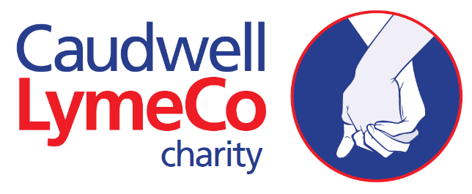
Innovation Fund 2021 Application Form

Instructions
Please complete form and return to: lymecocharity@caudwell.com along with any supporting information.

General Information
1a.
Application Title |  |  | Name of Organisation
Proposed start date |  |  | Proposed duration
1b.
Lay Abstract
1c.
Has this or a related application currently or previously been submitted elsewhere?  If yes, please provide details including the date of submission and current status. | Yes/No (remove as appropriate).
1d.
What impact and potential benefits will the research have on those living with Lyme disease?

- Applicant Details
2a.
Lead applicant name |  |  | Email & Contact no.
Organisation |  |  | Education/Qualification History
2b.
Funding history (please give details of all past grants awarded)
Publication history (in the last five years, plus any other publications directly relevant to this application)

- Co-applicants
Names, titles & organisations (please list)

- Collaborators & research team
4a.
Names & organisations of collaborators (please list) | Please include letters of support from collaborators with your application, if applicable

4b.
Please summarise the roles of the individuals in the research team

- Project details
5a.
Which of our research priorities does this project meet?
5b.
Background
5c.
Hypothesis
5d.
Objectives
5e.
Outcome measures
5f.
Impacts
5g.
Outputs – what do you intend to produce from your research?

5h.
What will be your measurements of success?

5i.
Please outline how the expected outcomes of the project might transfer to clinical practice.

5j.
Will the research be recruiting human participants? (If yes, please complete section below) | Yes | No
5k. Dissemination Plan
Please attach a Gantt chart or similar document with your application outlining the key steps, milestones and rough timeline for the proposed project. |  | Attach file with application form
5l. Innovation
Tell us why this research project is innovative.
If you are building on relatively new or existing discoveries, please include details of previous related research.
If recruiting human participants
Sample size calculation
Inclusion/exclusion criteria (including justification for exclusions)
Method of allocating participants to groups
Planned recruitment rate (including feasability analysis)

- Risks & Mitigation
Discuss any potential risks to the project and highlight mitigation strategies

- Involvement and engagement
Have people living with Lyme disease inputted into the design of the research?

Will people living with Lyme disease be involved in the conduct of the research?
How will results of the research be fed back to those participating and other people living with Lyme disease?

- Additional support
Is there any additional financial support for this application?
8a.
Institutional support
Support from another funder
Does the proposed project have any industrial support (including collaborations and donations)?
Other type of support
8b.
Is there the possibility of new Intellectual Property (IP) associated with the proposal? Yes/No
If yes, please provide information on the IP potential of your research.
Please detail the IP management plan (including approach to confidential data and publication planning)

Is there existing IP associated with the proposal? | Yes/No (delete as appropriate)
If yes, please provide information on the existing IP

- Finance & costs
Salaries
Consumables
Equipment
Overheads
Animals (if applicable)
TOTAL

- Research with humans & animals
10a.
Research involving humans
On 16 April 2018, HRA Approval became HRA and Health and Care Research Wales (HCRW) Approval and now applies to all project-based research taking place in the NHS in England and Wales. HRA approval applies where the NHS organisation has a duty of care to participants, either as patients/service users or NHS staff/volunteers. References to participants include people whose data or tissue is involved in a research project.
If your project is led from Northern Ireland, Scotland or Wales and involves NHS/HSC sites then you will not apply to the HRA. You should apply through the appropriate NHS/HSC permission process for that lead nation.
Will your research require HRA or equivalent approval? YES/NO
If no, please explain why this is the case.
If yes, is this already in place?
10b.
Research involving animals
Caudwell LymeCo is committed to the principles of reduction, replacement and refinement in animal studies. Before completing this section please read our policy on animal research (bottom of webpage).
Do your proposals include procedures to be carried out on animals covered by the Animals (Scientific Procedures) Act or animal tissue?
Have the following necessary approvals been given by the Home Office (in relation to personal, project and establishment licences) and other relevant ethical review bodies?
Name and number of animal species
What is the maximum severity of the procedures involved?
Please provide details of any procedures of moderate or substantial severity
Does the proposed research involve genetically modified animals?
Have the relevant Home Office project and personal licences been obtained?

10c.
Please justify the use of animals, the species and techniques proposed and the number of animals to be used per experiment. Please include details of sample size calculations and statistical advice sought for the number of animals required to reach statistical significance.
10d.
Will the proposed research lead to the advancement of the 3Rs (replacement, refinement or reduction in the use of animals)? If so please detail which of the Rs the proposed research will advance and how this will be achieved.

******Don’t forget to attach your Project Plan with key milestones and proposed timelines of the project.******

- Signatories
Finance Officer |  | Head of Department

Project applicant(s)
Date of Signature
 | MM |  | DD |  | YY

